Transformers TCG Deck Builder

# Contents:

**Introduction**

* + Program Purpose (Page 2)
  + Transformers Trading Card Game Rules Link (Page 2)

**Installation**

* + How To Install The Transformers TCG Deck Builder (Page 2-3)

**Controls**

* + Bindings List (Page 3-4)

**Viewing Cards In The Card List**

* + Viewing Bot Cards (Page 3-4)
  + Viewing Battle Cards (Page 4-5)

**Filtering Cards**

* + Filtering Bot Cards (Page 6-7)
  + Filtering Battle Cards (Page 7)

**Adding/Removing Cards**

* + Adding/Removing Bot Cards (Page 8-9)
  + Adding/Removing Battle Cards (Page 10)
  + Viewing Cards Added To The Deck (Page 10-11)

**Totals**

* + The Subtotals & Totals Section (Page 12)
  + Optional Limits (Page 13)

**The File Menu**

* + Opening A New Window (Page 14)
  + Closing The Program (Page 14)

Introduction

# Program Purpose:

The purpose of the Transformers TCG Deck Builder is to provide a deck building interface for the Transformers Trading Card Game using a small sample size of 32 cards provided to the user through the program.

# Transformers Trading Card Game Rules Link:

Rules for the Transformers Trading Card Game can be found at the link below.  
https://teamcovenant.com/learning/transformers-tcg/how-to-play-transformers-tutorial-demo

Installation

# How To Install The Transformers TCG Deck Builder:

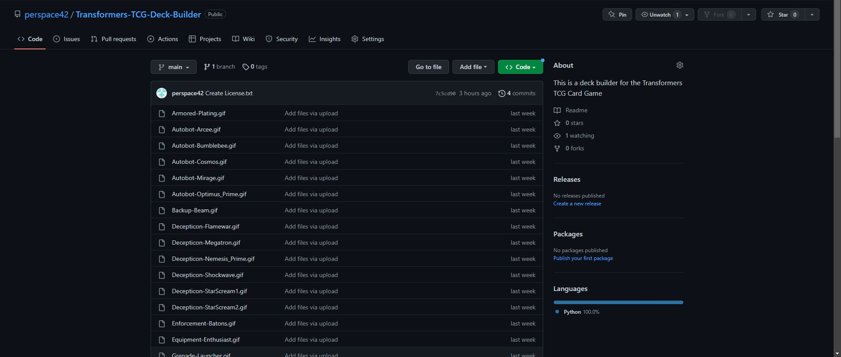 *Figure 1.0*

1. Open a web browser and go to the github repository using the link below: <https://github.com/perspace42/Transformers-TCG-Deck-Builder/tree/main>
2. Your screen should now display the files shown in Figure 1.0, Now starting from the top and being sure to scroll until reaching the bottom: download all of the files within the Transformers-TCG-Deck-Builder tab (not just the files displayed in Figure 1.0). Also be sure to place all of the downloaded files in the same file directory on your computer.
3. Run the FieldScottFinalProject.py file using the Integrated Developer Environment of your choice.
4. Check that the program displays on the screen, it should look identical to Figure 1.1 displayed below.

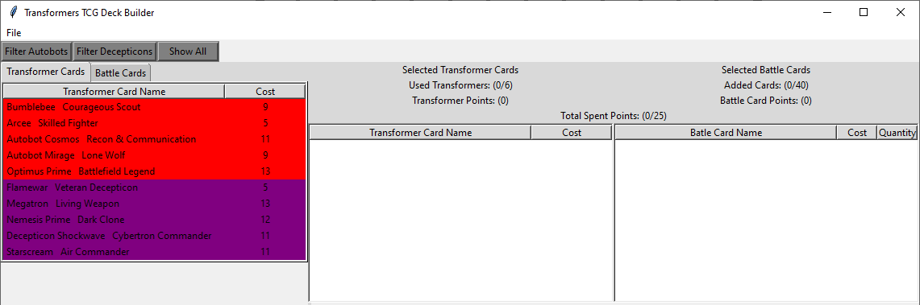 *Figure 1.1***Note:**If the program does not display or throws an error, double check to ensure that you are running the FieldScottFinalProject.py file. If the error persists, go back to the github repository using the link at step 1 and double check that you have installed every file within the Transformers-TCG-Deck-Builder repository. Otherwise Congratulations!!! you have successfully installed the program.

Controls

# Bindings List

<Single Mouse Left Click>: **Select** (Select A Card or Button or Tab)   
<Double Mouse Left Click>: **Add** (Add A Card To The Deck)  
<Mouse Right Click>: **Remove** (Remove A Selected Card From A Card List)  
<Mouse Scroll Wheel Up>: **Up (**Move the results displayed within a card list upward)  
<Mouse Scroll Wheel Down>: **Down (**Move the results displayed within a card list downward)

Viewing Cards In The Card List

# Viewing Bot Cards

As you can see in Figure 1.1 & Figure 1.2 a list of Bot Cards is now displayed towards the bottom left of the window in the card view list. This card list displays both Autobot and Decepticon Bot Cards, with Autobots being colored Red and Decepticons being colored Purple. To display the image of any of these cards:

1. Move the mouse pointer over the bot card you wish to view
2. Click the **Select** mouse button then Release the **Select** mouse button

The window will automatically resize to display the Bot Card you have selected after you have completed the instructions. (In Figure 1.2 Bumblebee Courageous Scout is selected)

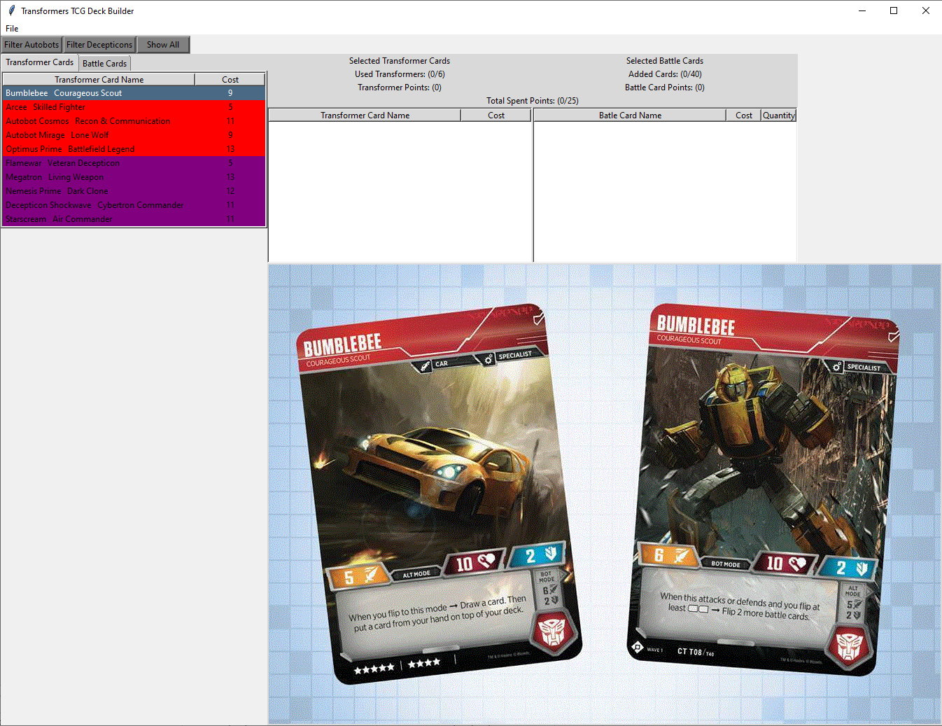

*Figure 1.2*

# To view the remaining Bot Cards:

1. Place the mouse cursor over the card view list and use the **Down** binding to display the remaining Bot Card.
2. When you are finished viewing the remaining bot card use the **Up** binding to display the other Bot Card.

# Viewing Battle Cards

Locate the card view tabs just above the card view list.  
(circled in figure 1.3)

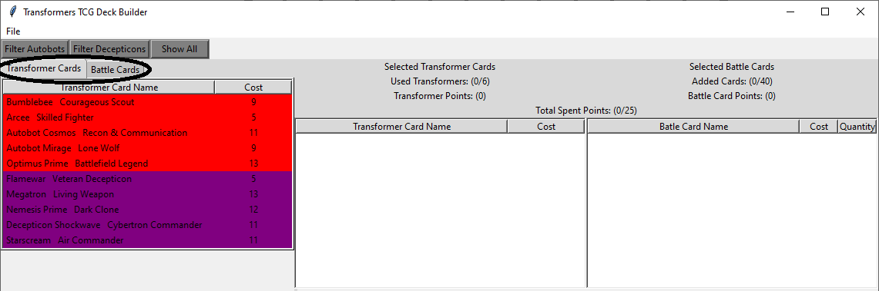

*Figure 1.3*

When the Transformer Cards Tab is selected it is only possible to view Bot Cards in the card view section, and when the Battle Cards Tab is selected it is only possible to view Battle Cards in the card view section.

to switch to the Battle Cards Tab :

1. Place the mouse cursor over the tab labeled Battle Cards and use the **Select** mouse button

After which point battle cards will be displayed in the card view list. See Figure 1.4 for details.

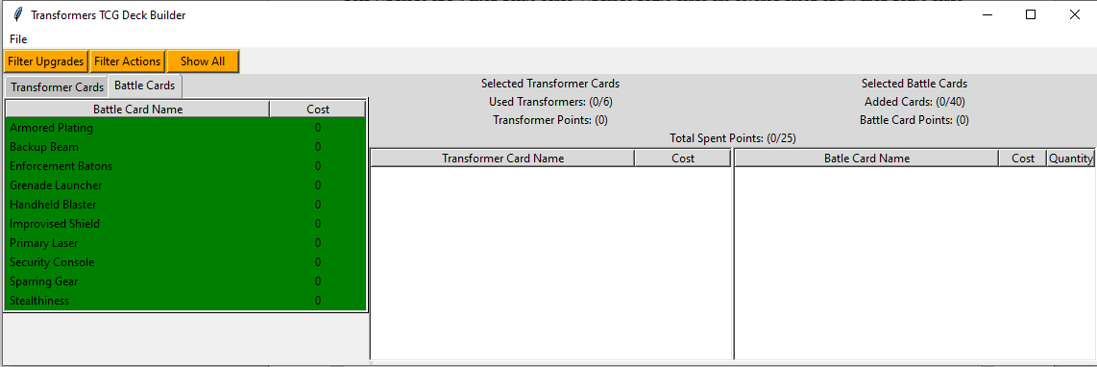

*Figure 1.4*

By default only Upgrade Battle Cards will be displayed in the card view section however to view the remaining Action Battle Cards:

1. Place the mouse cursor over the card view list and use the **Down** binding to display the remaining Battle Cards
2. When you are finished viewing the remaining bot card use the **Up** binding to display the other Battle Cards

As can be seen in Figure 1.4 a list of Battle Cards is now displayed towards the bottom left of the window in the card view list. This card list displays both Upgrade and Action Battle Cards, with Upgrades being colored Green and Actions being colored Cyan. to display the image of any of these cards:

1. Move the mouse pointer over the Battle Card you wish to view.
2. Click the **Select** mouse button then Release the **Select** mouse button.

The window will automatically resize to display the Battle Card you have selected (In Figure 1.5 Grenade Launcher has been selected)

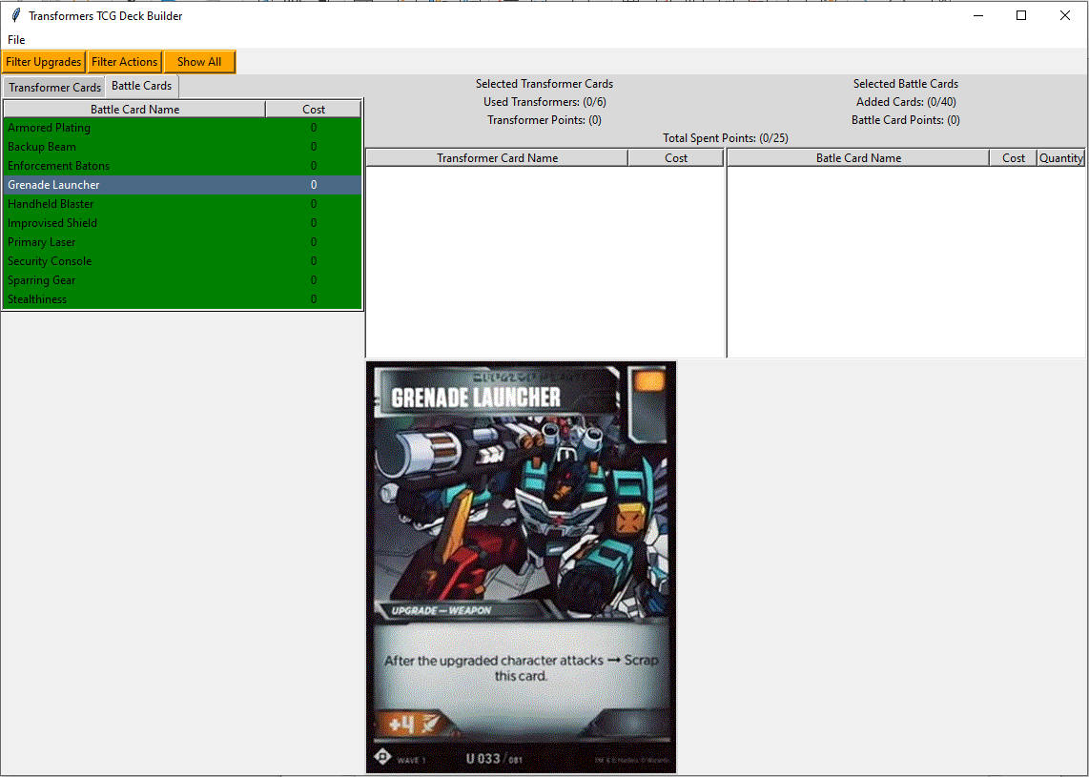

*Figure 1.5*

**Helpful Reminder (How To Switch Back To Transformer Cards Tab):**

To switch back to the Transformer Cards Tab place your mouse pointer directly over the tab labeled Transformer Cards and click the **Select** mouse button. In Figure 1.6 below the Transformer Cards tab has been circled.

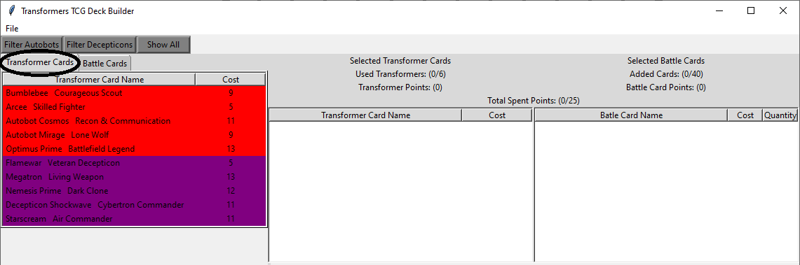

*Figure 1.6*

Filtering Cards

# Filtering Bot Cards

When the Transformers Card Tab is selected, you may filter the Bot Cards contained in the card view list by Autobot Bot Cards, Decepticon Bot Cards, or All Bot Cards. To filter the Bot Cards within the card view list:

1. Verify that the Transformer Cards Tab (Circled In Figure 1.6) is selected
2. Locate the filter buttons (circled in Figure 1.7)

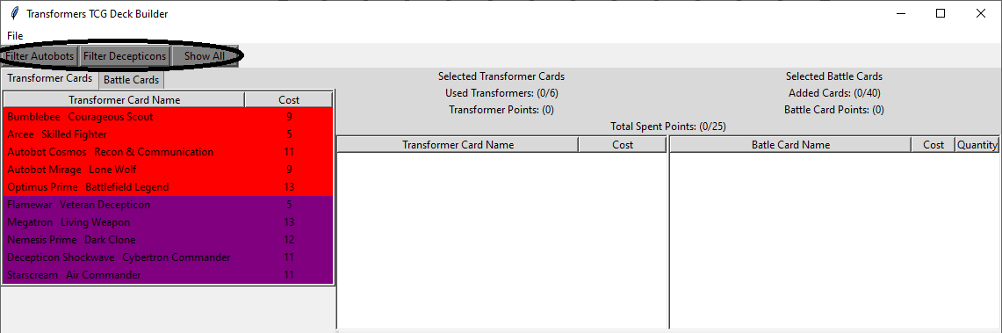

*Figure 1.7*

1. Select the desired filter to apply to the list from the numbered options below.
   1. To see only Autobot Bot Cards, select the left filter button labeled: Filter Autobots. (Results shown below in Figure 1.8)

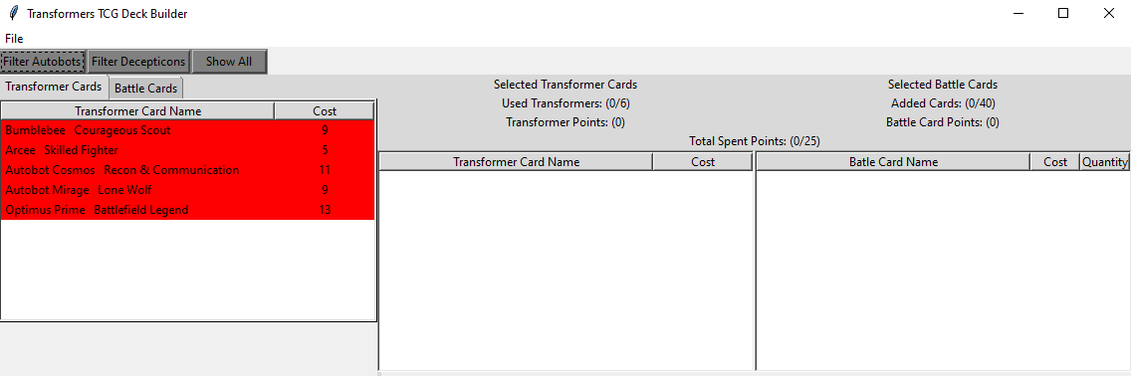

*Figure 1.8*

* 1. To see only Decepticon Bot Cards, select the middle filter button labeled: Filter Decepticons. (Results  
     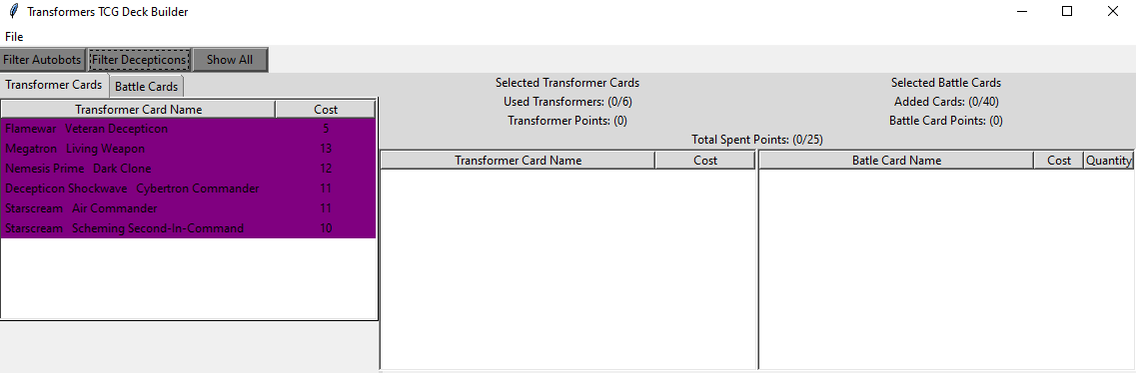 shown below in Figure 1.9)

*Figure 1.9*

* 1. To switch back to viewing both Autobot & Decepticon Bot Cards select the right filter button labeled: Show All.(Results will be identical to Figure 1.7)

# Filtering Battle Cards

When the Battle Card Tab has been selected, it is possible to filter the Battle Cards contained in the card view list by Upgrade Battle Cards, Action Battle Cards, or All Battle Cards. to filter the Battle Cards within the card view list:

1. Verify that the Battle Cards Tab (The Tab To The Right Of The Circled Tab In Figure 1.6) has been selected
2. Locate the filter buttons circled in Figure 2.1

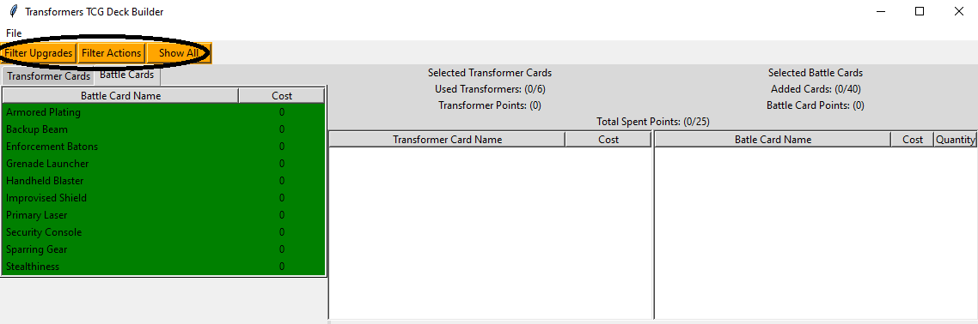

*Figure 2.1*

1. Select the desired filter to apply to the list from the numbered options below
   1. To see only Upgrade Battle Cards select the most leftward filter button labeled: Filter Upgrades. (Results Shown Below in Figure 2.2)



*Figure 2.2*

* 1. To see only Action Battle Cards select the middle filter button labeled: Filter Actions. (Results Shown B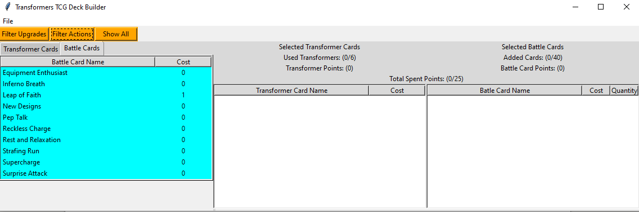elow in Figure 2.3)

*Figure 2.3*

* 1. To switch back to viewing both Upgrade & Action Battle Cards select the most rightward filter button labeled: Show All.(Results will be identical to Figure 2.1)

Adding/Removing Cards

# Adding/Removing Bot Cards

To add a Bot Card to the deck mouse over the desired Bot Card in the card view section then click the **Add** mouse binding (In Figure 2.4 Megatron Living Weapon and Nemesis Prime Dark Clone Have each been added to the deck).

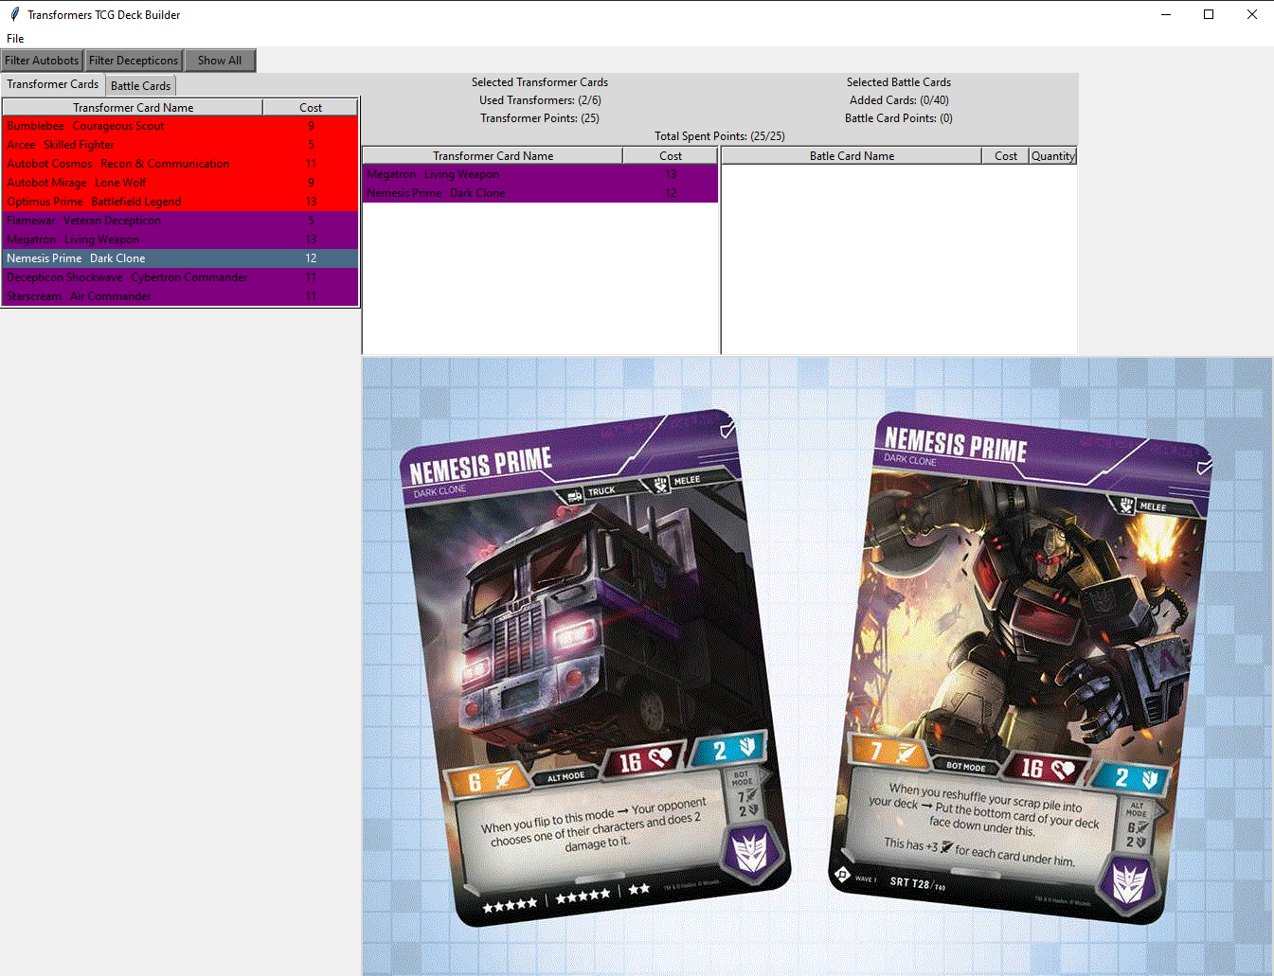

*Figure 2.4*

To remove a Bot Card from the deck mouse over the desired Bot Card in the card select section then click the **Remove** mouse binding (In Figure 2.5 Megatron Living Weapon has been removed from the deck).

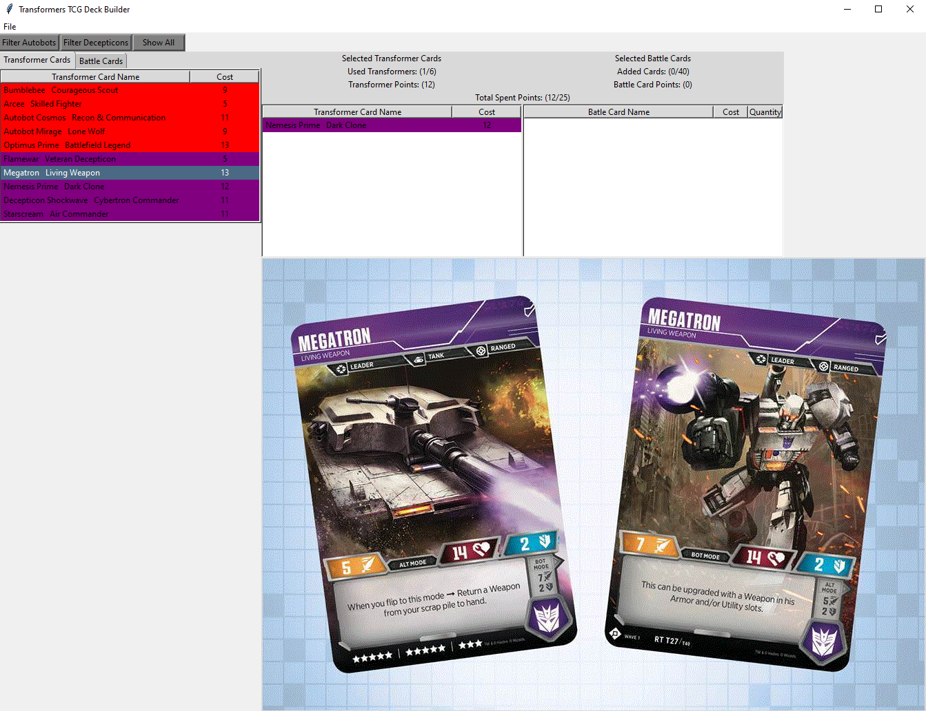 *Figure 2.5*

**Helpful Reminder (Bot Card Limits)**  
Per the rules of the Tranformers TCG it is not permitted to have two of the exact same Bot Card in the same deck. This program reflects those rules and will not allow two of the exact same Bot Card in the same deck.

# Adding/Removing Battle Cards

To add a Battle Card to the deck, mouse over the desired Battle Card in the card view section then click the **Add** mouse binding (In Figure 2.6 Strafing Run has been added)

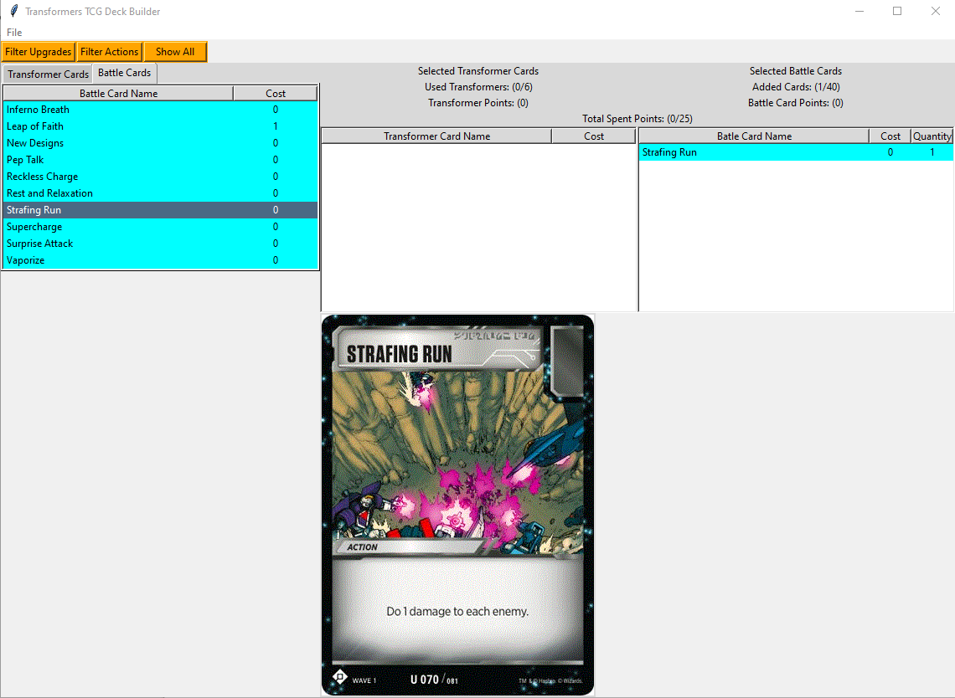 *Figure 2.6*

To remove a Battle Card from the deck mouse over the desired Battle Card in the card selection section then click the **Remove** mouse binding.

**Helpful Reminder (Battle Card Limits)**By the rules of the Transformers TCG, a deck is only allowed to contain 3 copies of the exact same Battle Card. (This is why the Battle Card selection section contains a quantity column) This program reflects that rule and will not allow the user to add more than 3 of the exact same battle card to the deck.

# Viewing Cards Added To The Deck

To view cards that are added to the deck, mouse over the desired Bot or Battle Card within the card selection section. Then click the **Select** mouse binding(In Figure 2.7 Decepticon Shockwave Cybertron Commander has been selected from the card selection section)

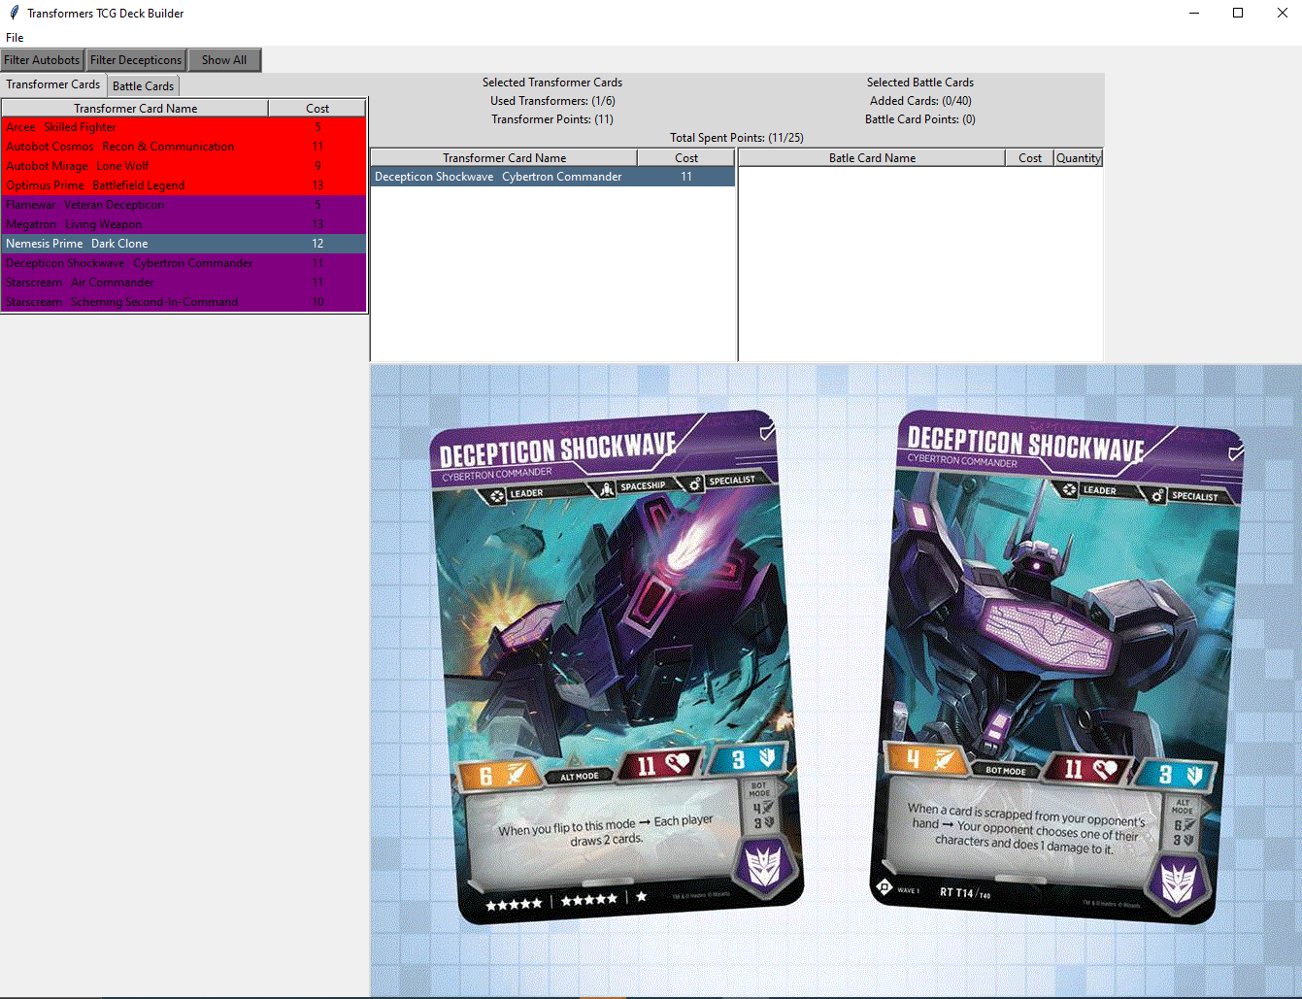 *Figure 2.7*

**Helpful Reminder (Card Selection Precedence)**In Figure 2.7, both Nemesis Prime Dark Clone and Decepticon Shockwave Cybertron Commander have been selected, but the only image displayed is Decepticon Shockwave Cybertron Commander. This is due to Card Selection Precedence, which states that when multiple cards are selected, the card selected last will be displayed on the screen.

**Totals**

# The Subtotals & Totals Section

When Bot and Battle Cards are added or removed from the deck the program keeps track of the number and cost of the bot and battle cards currently added in the Totals Section (In Figure 2.8 circled below)

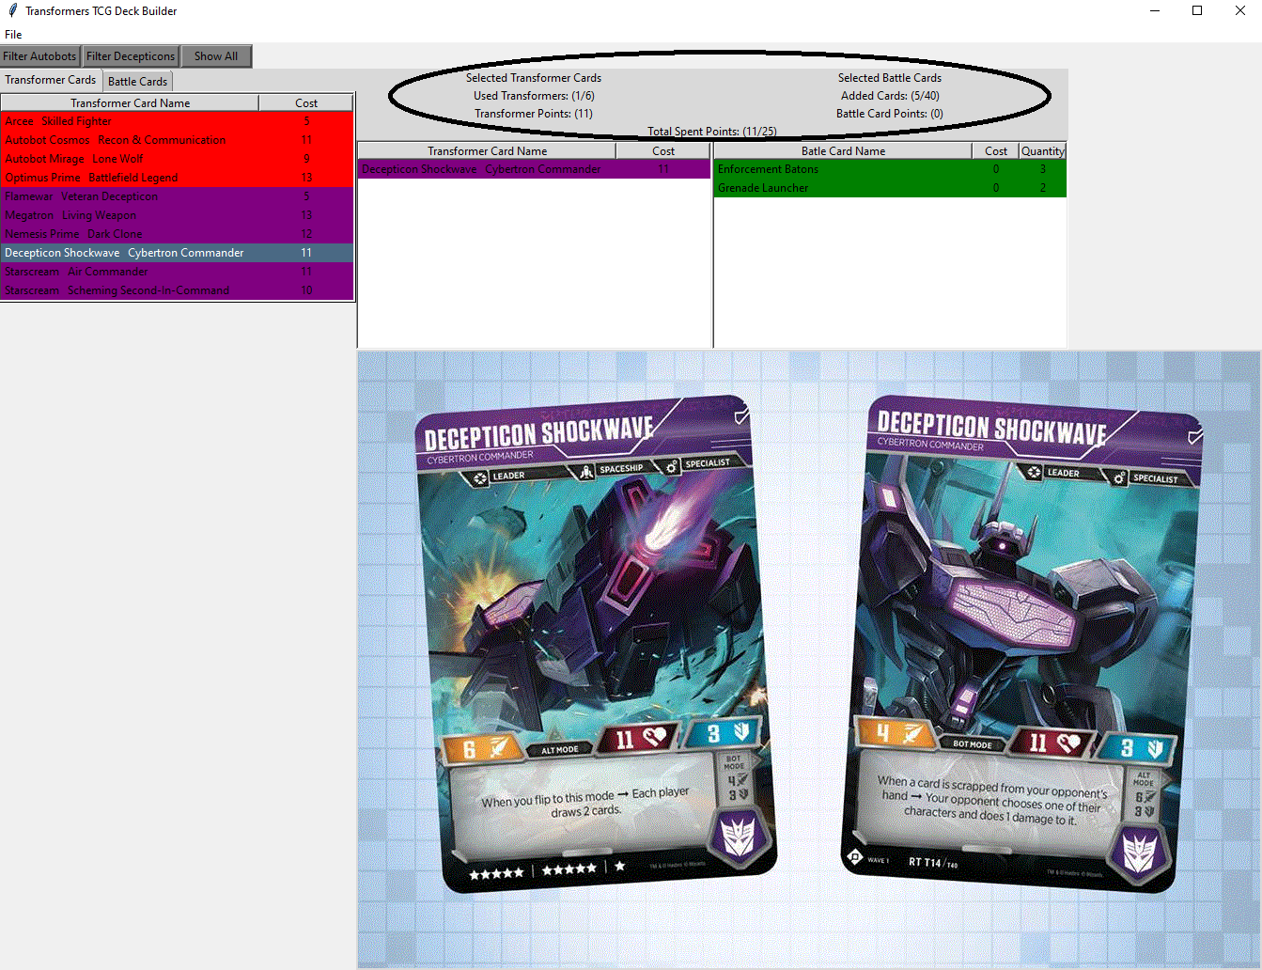 *Figure 2.8*

in Figure 2.8, the Used Transformers label displays (1/6), the Transformer Points label displays (11), The Added Cards (Battle Cards) label displays (5/40), The Battle Card Points label displays (0) and the Total Spent Points label displays (11/25). This is reflective of the cost and quantity of the added cards in the deck.

When a Bot Card is added or removed the Bot Subtotals section (Located directly under the label: Selected Transformer Cards) and the Totals section (Located at the label: Total Spent Points) will adjust accordingly.

When a Battle Card is added or removed the Battle Subtotals section (Located directly under the label: Selected Battle Cards) and the Totals section (Located at the label: Total Spent Points:) will adjust accordingly.

# Optional Limits

Figure 2.9 shows the ability to add more points and a larger quantity of Bot and Battle Cards than the totals in the Used Transformer, Added Cards, and Total Spent Points labels.

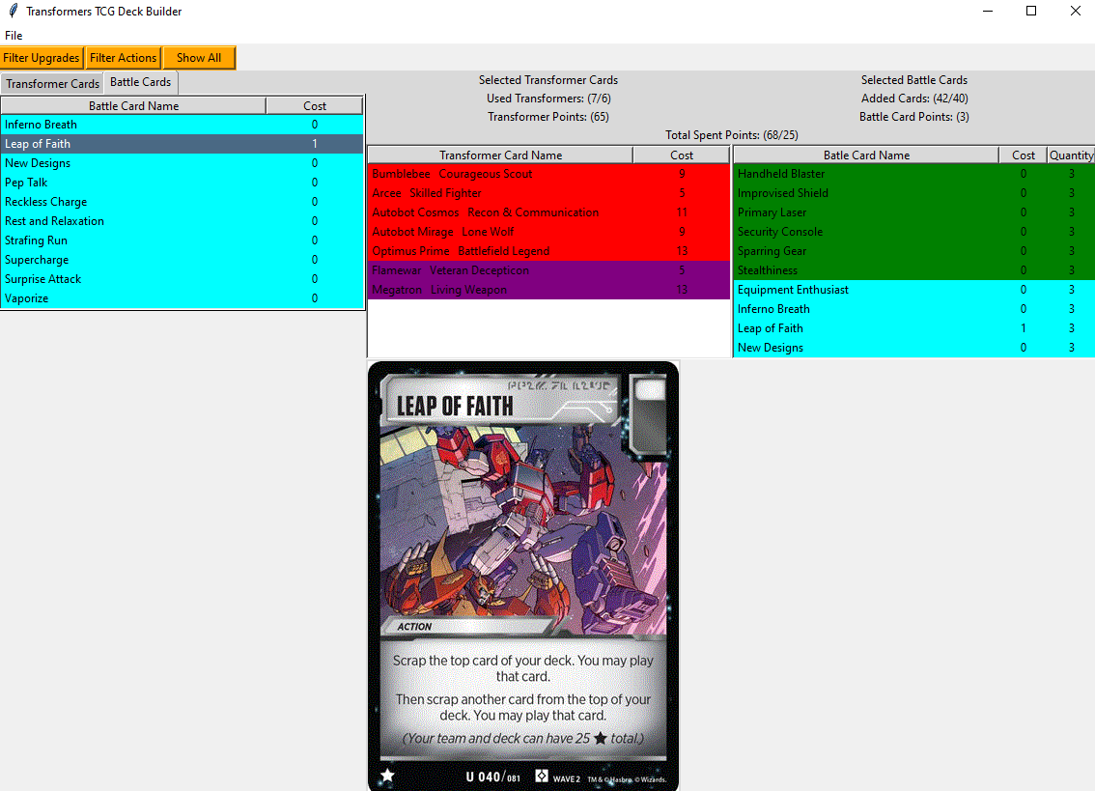 *Figure 2.9*

In Figure 2.9, the Used Transformers section shows (7/6), The Added Cards section shows (42/40), and The Total Spent Points shows (68/25). In the Transformers TCG rules a standard deck has up to 6 Bot Cards, 40 Battle Cards and 25 points.

The Transformers TCG Deck Builder does not stop the user from adding more points and/or Bot Cards than standard games allow. (to vary the time spent on a game)

This program does enforce no duplicate Bot Cards and no more than 3 duplicate Battle Cards per deck. (these rules are critical to game balance)

The File Menu

# Opening A New Window

To open a new window click the File Menu with the left mouse button (circled in Figure 3.0)

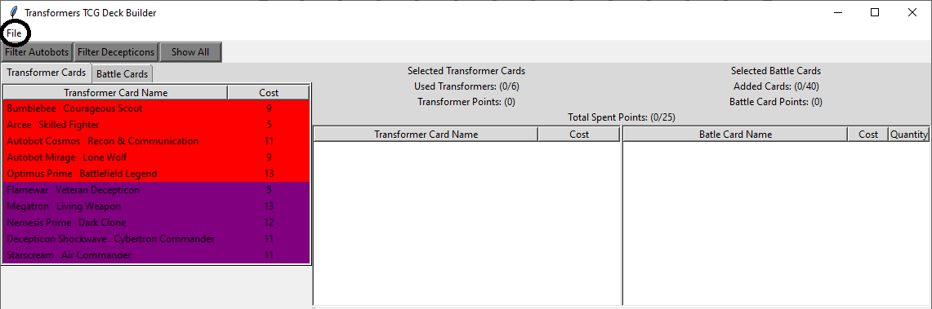 *Figure 3.0*

Then click the option labeled New with the left mouse button (The screen should now display two windows   
as in Figure 3.1).

# Closing The Program

To exit the program, click the File Menu with the left mouse button. Then click the option labeled Exit with the left mouse button.